Name
Course Name
Course No
Date

Hooke’s Law.

Objective.
To determine the spring constant of a spring using two methods.
List of Apparatus.
- Chronometer.
- Spring.
- Hanging Weights.
- Meter ruler.
- Stand clamp.
Theory and Equations.
In this experiment of measuring spring constant we will use two theories.
On the first method, we will use a spring with a hanging mass to measure the stretch. While the mass is at rest, we are going to measure the total stretch achieved by it. The formula used is $F=-kx$. F is the force acting mg and x is the distance the spring is stretched. The spring constant k can be found by knowing the mass, local acceleration and x.
In the second method, the spring constant is measured using the oscillation of a mass over a hanged spring. The formula used $k=\frac{4π^{2}T^{2}}{m}$. T is the period of oscillation: The time it takes for the system to reach the same position and velocity. We can know K by knowing the mass and the period. Since we do not have a comparable for our percentage of error, we are going to use both our results for k towards each other. We will use both results for k towards each other, therefore we will use the formula $\left\lceil \frac{k1+k2}{0.5 .(k1+k2)}\right\rceil$
Summary of the procedure.
For the first method.
- Setup a stand clamp on a table surface.
- Secure the spring to the top enabling it to hang freely. For the first experiment first measure the length of the spring without any mass hanging from it, hence making sure it gets restored to its original state once the mass is removed.
- Measure 15 hanging masses and calculate K for all the measures for the purposes of getting a more accurate average. Create a plot of F vs y.

For the second method.

- Hang the spring secured at the top and attach a mass.
- Start a vertical oscillation and measure and measure a period of 10 times per mass.
- Measure the average in order to get a more accurate results.

Data and observation.
The following is the data recorded from the experiment.
Length of the Long spring un-stretched = 0.053m
Length of the short spring un-stretched = 0.027m
Trial | Mass (kg) | Stretch (m) | T (s) | Stretch (m) | T (s)
1 | 0.06 | 0.179 | 0.887 | 0.225 | 0.876
2 | 0.065 | 0.196 | 0.917 | 0.238 | 0.861
3 | 0.07 | 0.208 | 0.95 | 0.239 | 0.953
4 | 0.075 | 0.227 | 0.988 | 0.268 | 0.916
5 | 0.08 | 0.234 | 1.007 | 0.273 | 0.934
6 | 0.085 | 0.252 | 1.04 | 0.299 | 0.996
7 | 0.09 | 0.265 | 1.005 | 0.297 | 0.979
8 | 0.095 | 0.284 | 1.078 | 0.323 | 0.980
9 | 0.1 | 0.295 | 1.117 | 0.326 | 1.021
10 | 0.11 | 0.325 | 1.167 | 0.359 | 1.112

$$Data Analysis.$$
$$F_{x}=-kX$$
$$X=(Stretched Length-original Length)$$
$$F=mg$$
For the data analysis check on the page attached

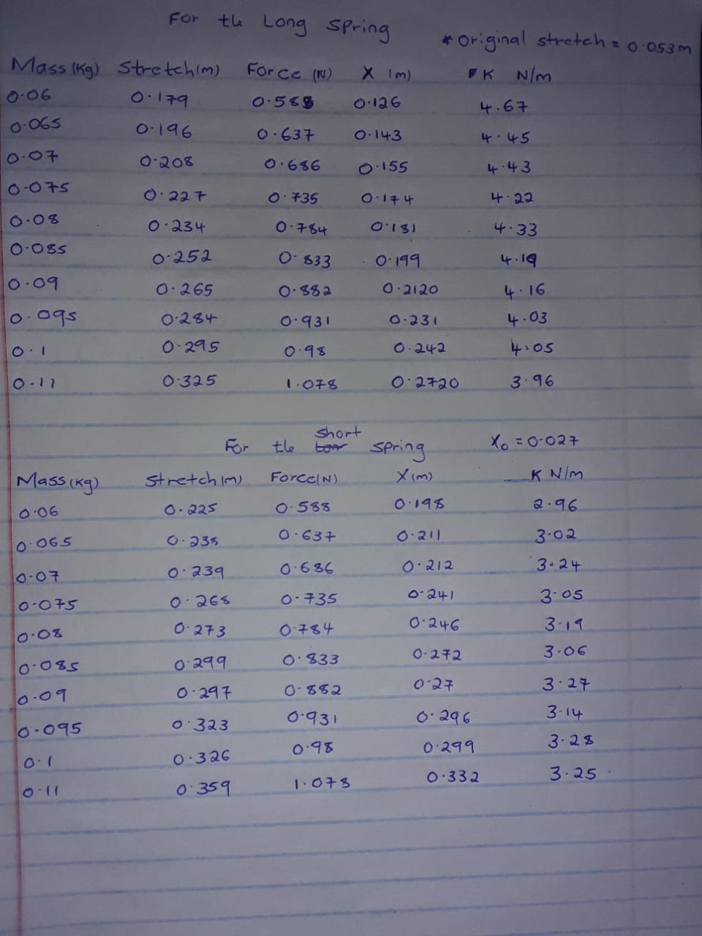

$$Results.$$
Spring constants for the first experiment (Hanging mass Experiment).
Trial | K For the long spring (N/m) | K For the short spring (N/m)
1 | 4.67 | 2.96
2 | 4.45 | 3.02
3 | 4.43 | 3.24
4 | 4.22 | 3.05
5 | 4.33 | 3.19
6 | 4.19 | 3.06
7 | 4.16 | 3.27
8 | 4.03 | 3.14
9 | 4.05 | 3.28
10 | 3.96 | 3.25

$$A plot of the force applied against the length Stretched$$
Graph for the long spring.
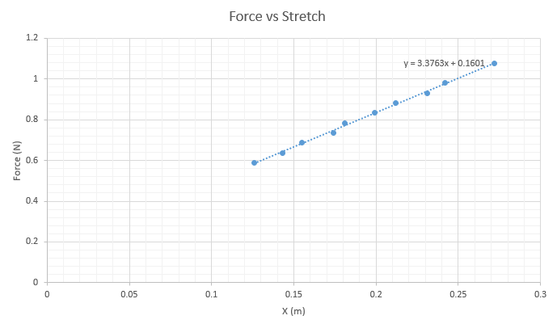
Graph for the short spring.
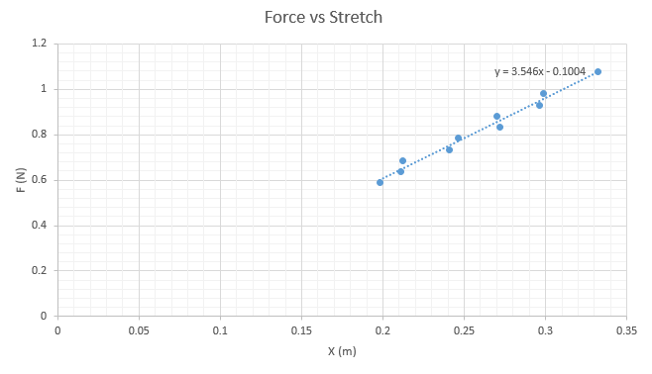

$$Conclusion.$$
The differences in the value of the spring constant are as a result of changes in temperature, the metal properties of the spring and also as a result of human error. The average spring constant for the two springs in the graph is the slope of the graphs.

